AR Report of Yuzhou Shao

Under the guideline of Professor Smolic and Dr. Young

Student name: Yuzhou Shao

Student id: 19322035

Project Includes:

Default Project 2 and Exercise 3

Youtube Demo Links:

Augmented Reality Virtual Field Trip Demo CS7GV04 <https://youtu.be/U6mJCsoyxaU>

Augmented Reality CS7GV4 Exercise 3 Demo - Trinity College Dublin <https://youtu.be/r76qgM-IX1o>

**Abstract:**

Default Project 2

I have completed the Virtual Field Trip AltspaceVR. Below is one of my output with the scene of the DCU landmark.

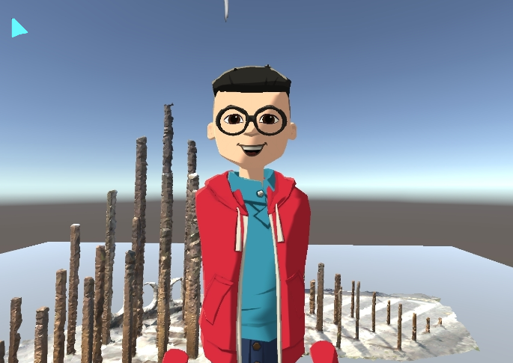

**Exercise 3:**

And also, I have followed the steps and algorithms of AR_OpenCV, given from Blackboard, to augmented an object in my scene using a chessboard as a reference tracking system. Below are some of my outputs.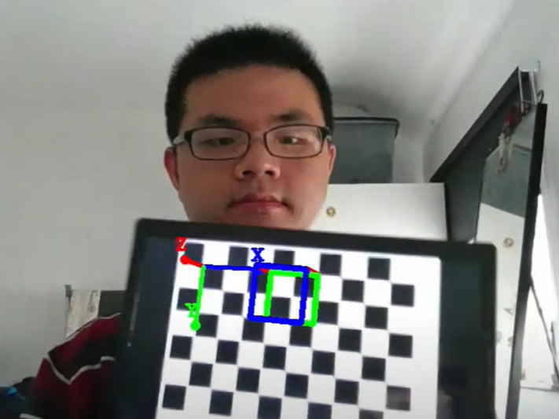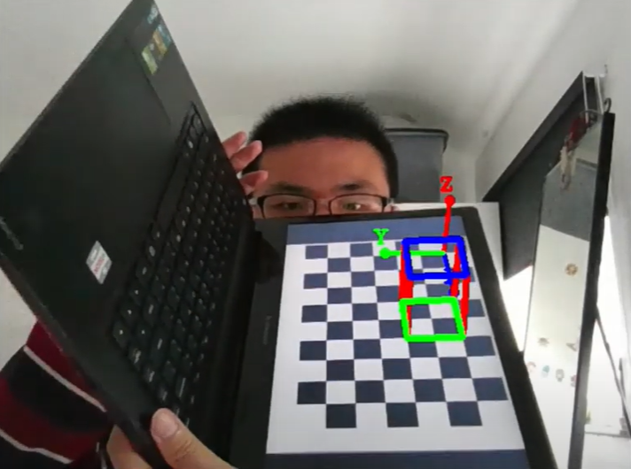

**Explanations:**

Virtual Field Trip on AltspaceVR

I have clicked 220 pictures surround the College landmark of Dublin City University, which is the closest and most easily accessible landmark to my house, during the current lockdown period. Using based on the default algorithm from Meshroom, a naïve 3d model I constructed.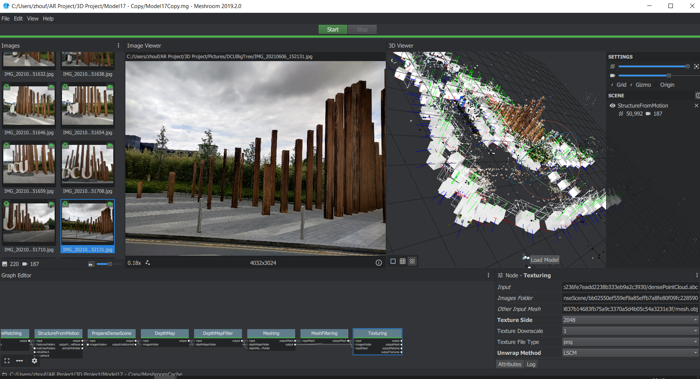

I have evaluated the properties of different elements of the 3D reconstruction (SfM) algorithms, then referenced several papers below to optimize the algorithm's performance and process.

Geometric Algorithms for 3D Interface Reconstruction [ahn_geometry.pdf (lanl.gov)](https://cnls.lanl.gov/~shashkov/papers/ahn_geometry.pdf)

"Soltani, A. A., Huang, H., Wu, J., Kulkarni, T. D., & Tenenbaum, J. B. Synthesizing 3D Shapes via Modeling Multi-View Depth Maps and Silhouettes With Deep Generative Networks. In Proceedings of the IEEE Conference on Computer Vision and Pattern Recognition (pp. 1511-1519)". 6 March 2020.

[(PDF) 3D surface reconstruction using HMH algorithm | Helene COQUEUGNIOT - Academia.edu](https://www.academia.edu/45681098/3D_surface_reconstruction_using_HMH_algorithm)

For example, to reduce the time-consuming while processing and eliminate the potential abnormal surfaces in the output.

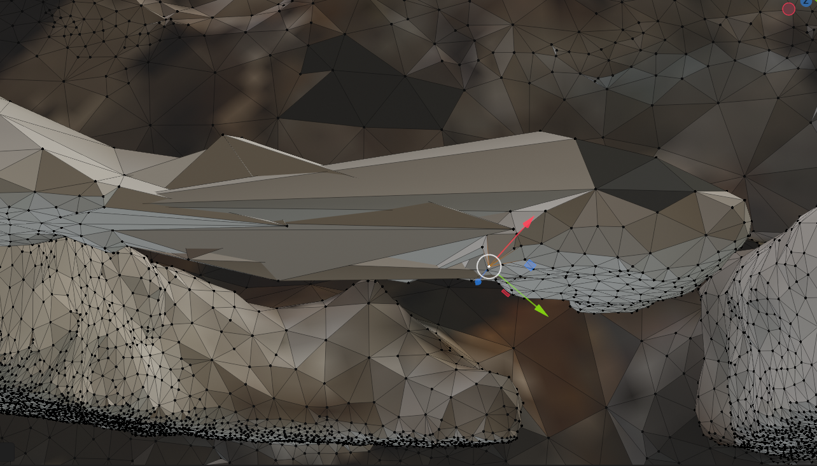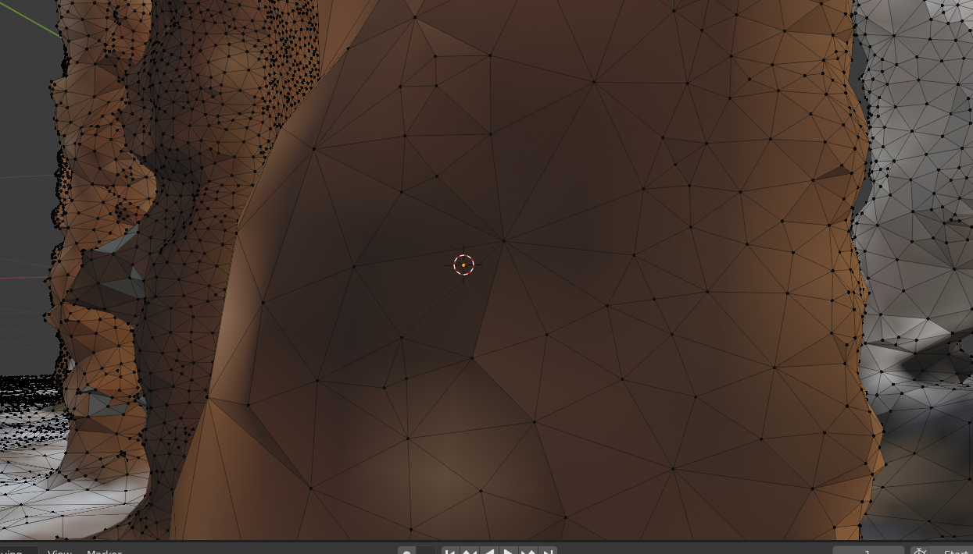

Next step, I imported the model to Blender to experiment with the performances I attempted to update on Meshroom.

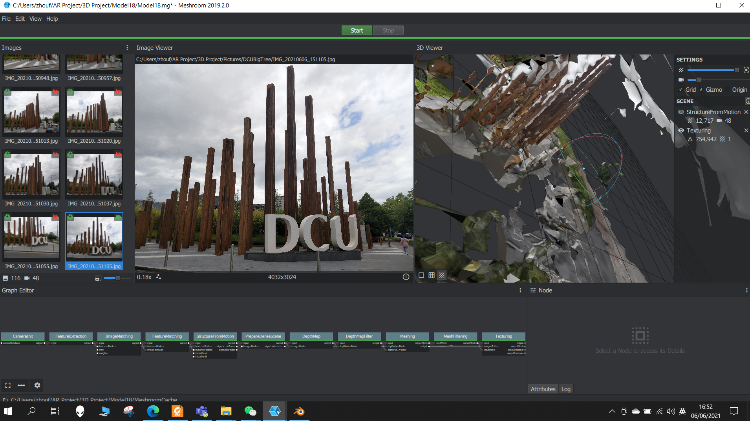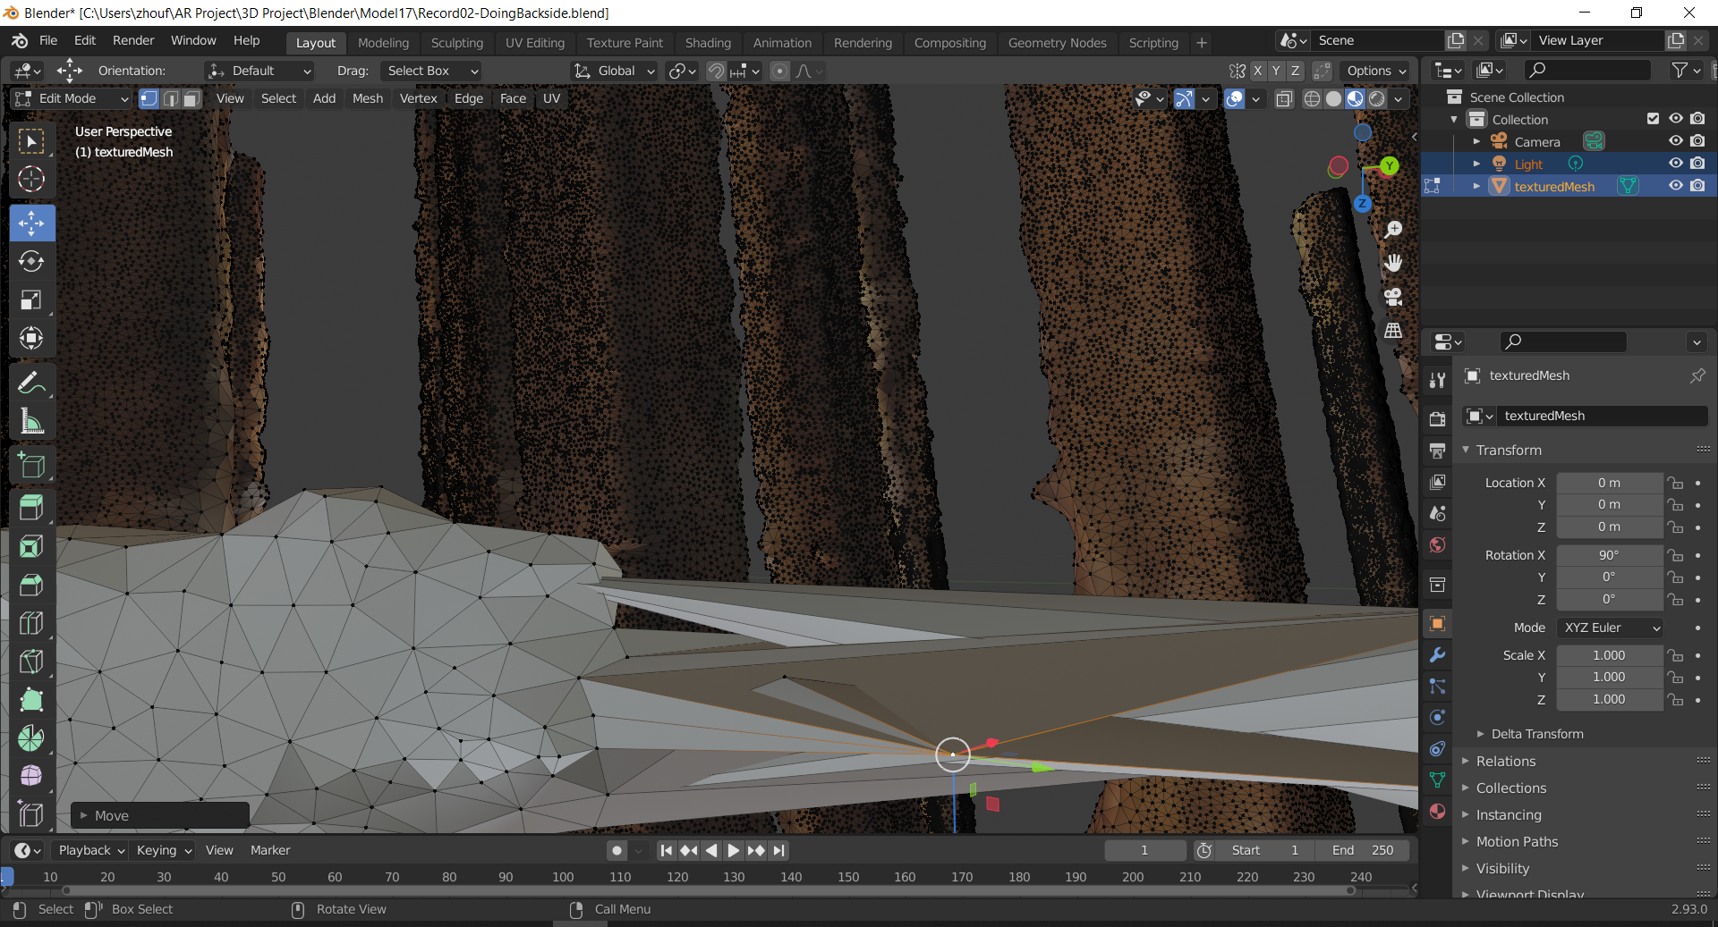

For comparison, I also tested the parameters from Texturing, which is different from Dr. Young’s tutorial. For example, I set the Texture Side as 8192, the Texture Downscale as 2, the Texture File Type is png, and Unwrap Method as Basic other than LSCM. I made permutations of these different parameters and executed them on various versions of Meshroom.

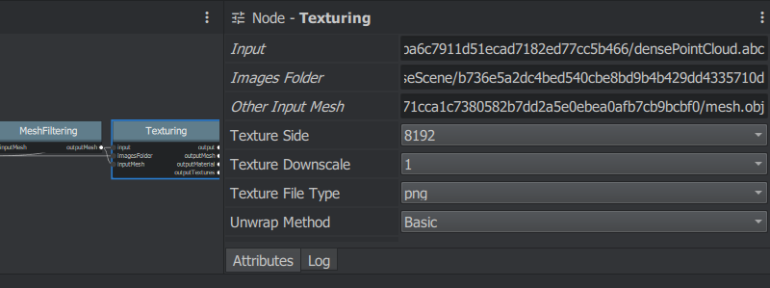

After accumulated 24 types of experiments in different parameters or versions for 52 hours attempting, I discovered that the latest versions of Meshroom.exe could never get the output no matter how I change the parameters. Therefore, it is extremely important to use the version of 2019.2.0. Otherwise, with the new versions, the process bar would always freeze at 98%. Even I waited for two entire nights. The remaining 2% can never be processed.

Moreover, I discovered that if users use mobile phones rather than digital cameras to take pictures, no matter how the mobile phone is on Android or iPhone. On the top left corner of each image, it always shows a yellow mark rather than green. A warning shows SerialNumber metadata is missing.

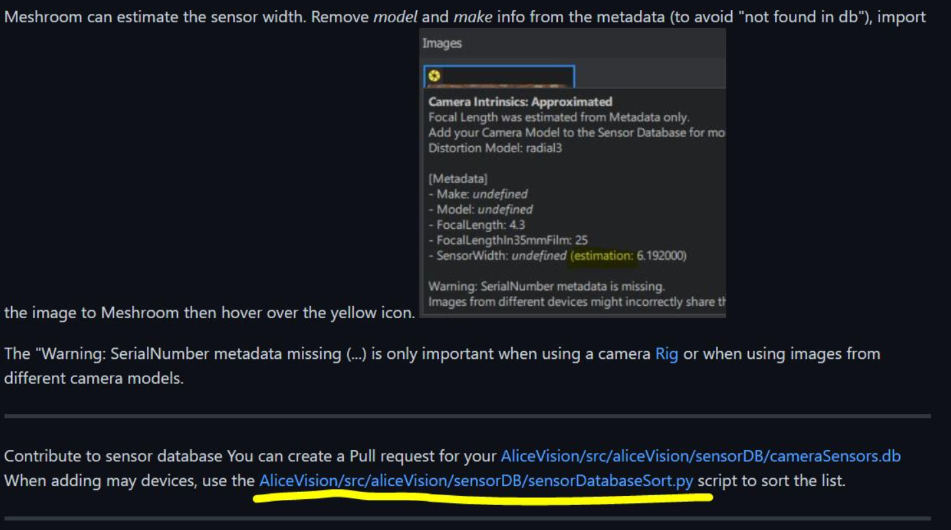

Above is a Screenshot taken from Github

The warning may potentially make over 50% of the images input by a user not be able to recognized by the algorithm.

To solve this issue, thank to Dr.Young, I accessed the directories of Meshroom-2019.2.0/aliceVision/share/aliceVision, and found cameraSensors.db, and added an extra entry of the model name of the mobile phone.

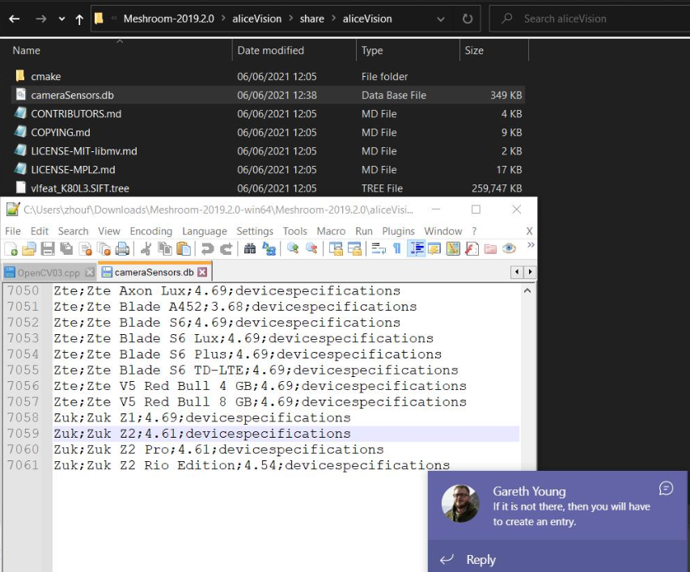

For example, my phone model is Vivo1804, I added below entry to the camera database:

Vivo;Vivo 1804;5.0;devicespecifications

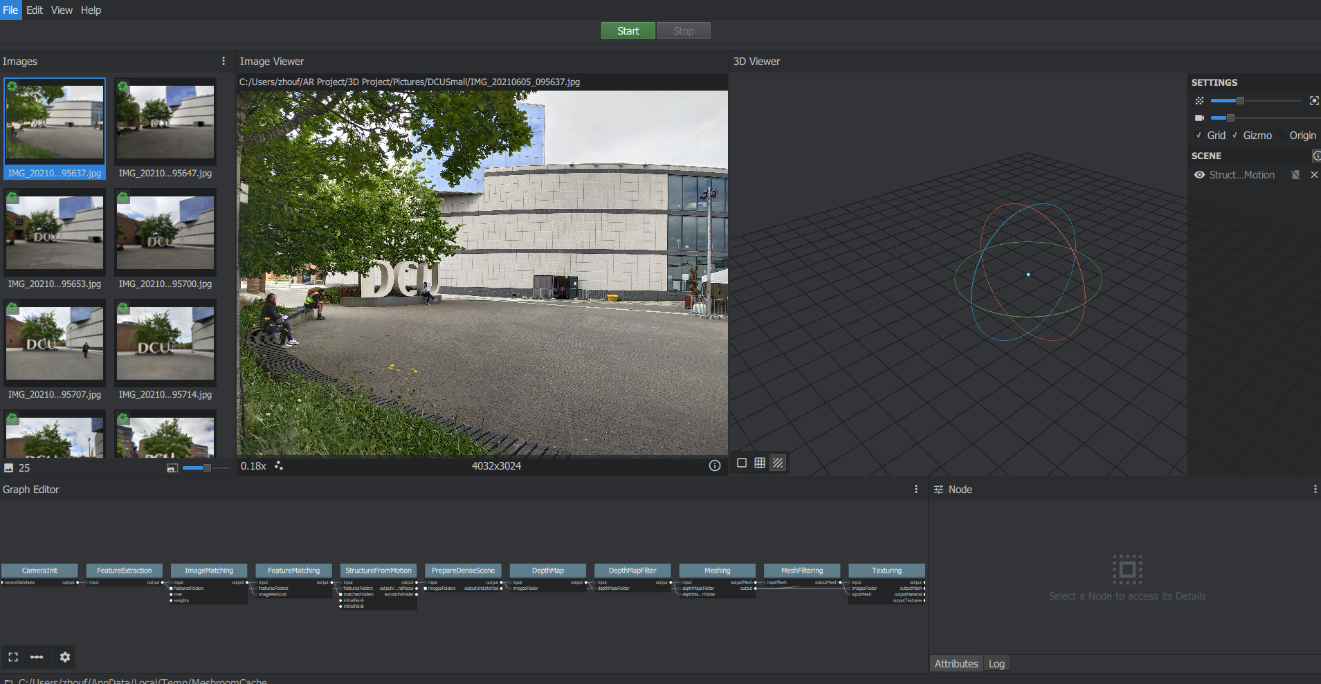

After that, there are no more warnings. So, solving these issues, I tested different scenes in Meshroom.exe with the trying of my optimized algorithms, referenced the papers I mentioned earlier.

Next, I have trimmed the model's output from Meshroom in Blender to make it suitable for visual appearance.

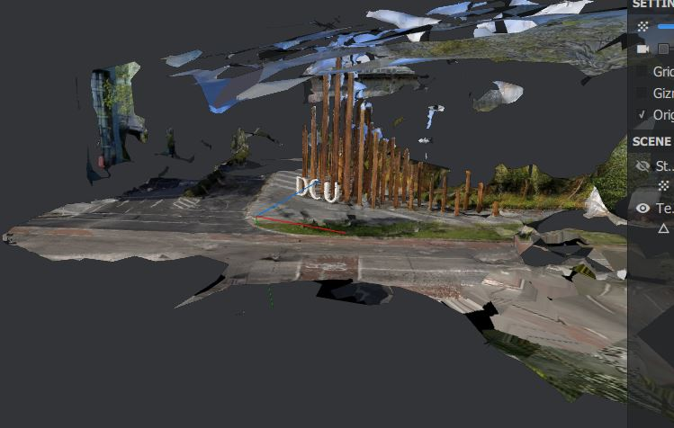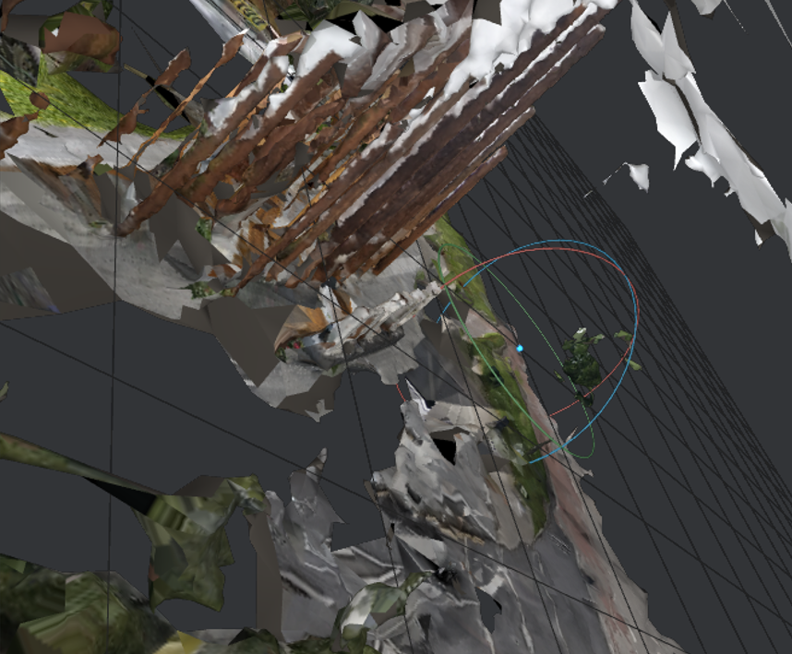

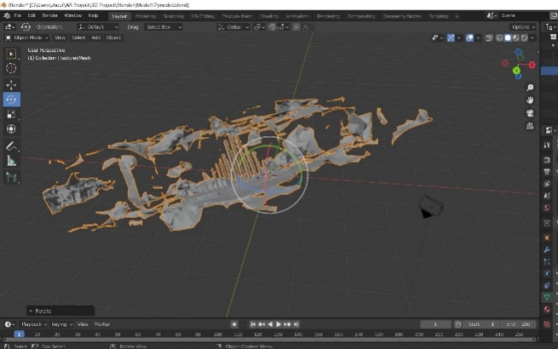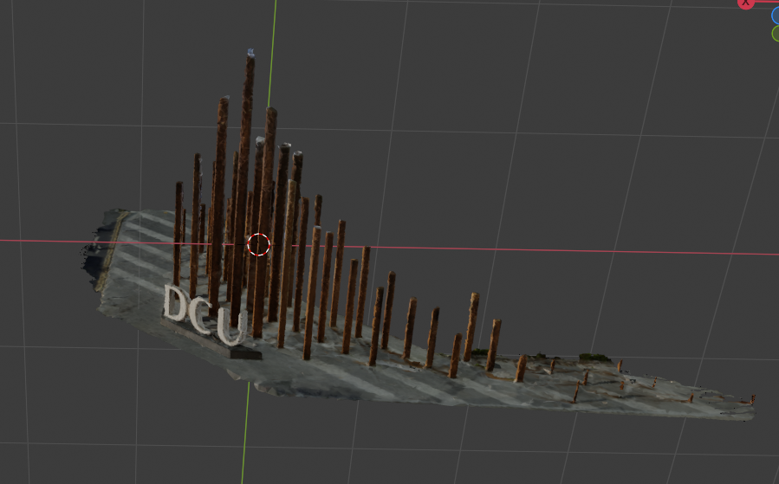

I also adjusted the triangle of some of the surfaces manually to cover the strange surface that was generated properly.

After complete Blender, I downloaded several free 3D models and constructed the surrounding environments in Unity. To make the scene as realistic as the real scene in Dublin City University, to enhance the AltspaceVR user experience.

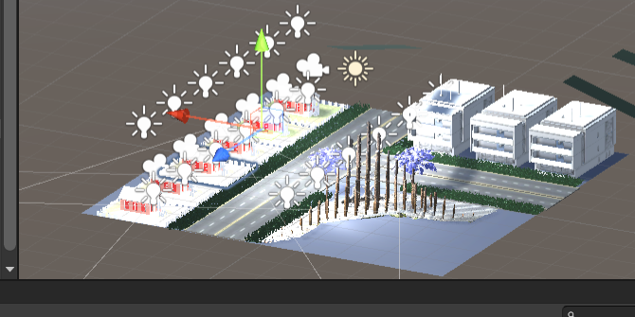

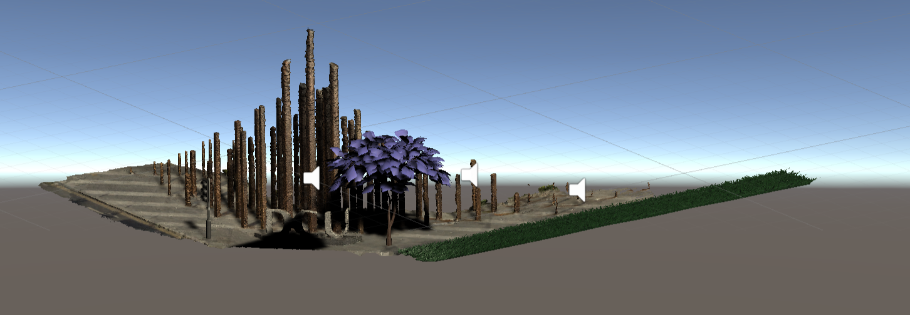

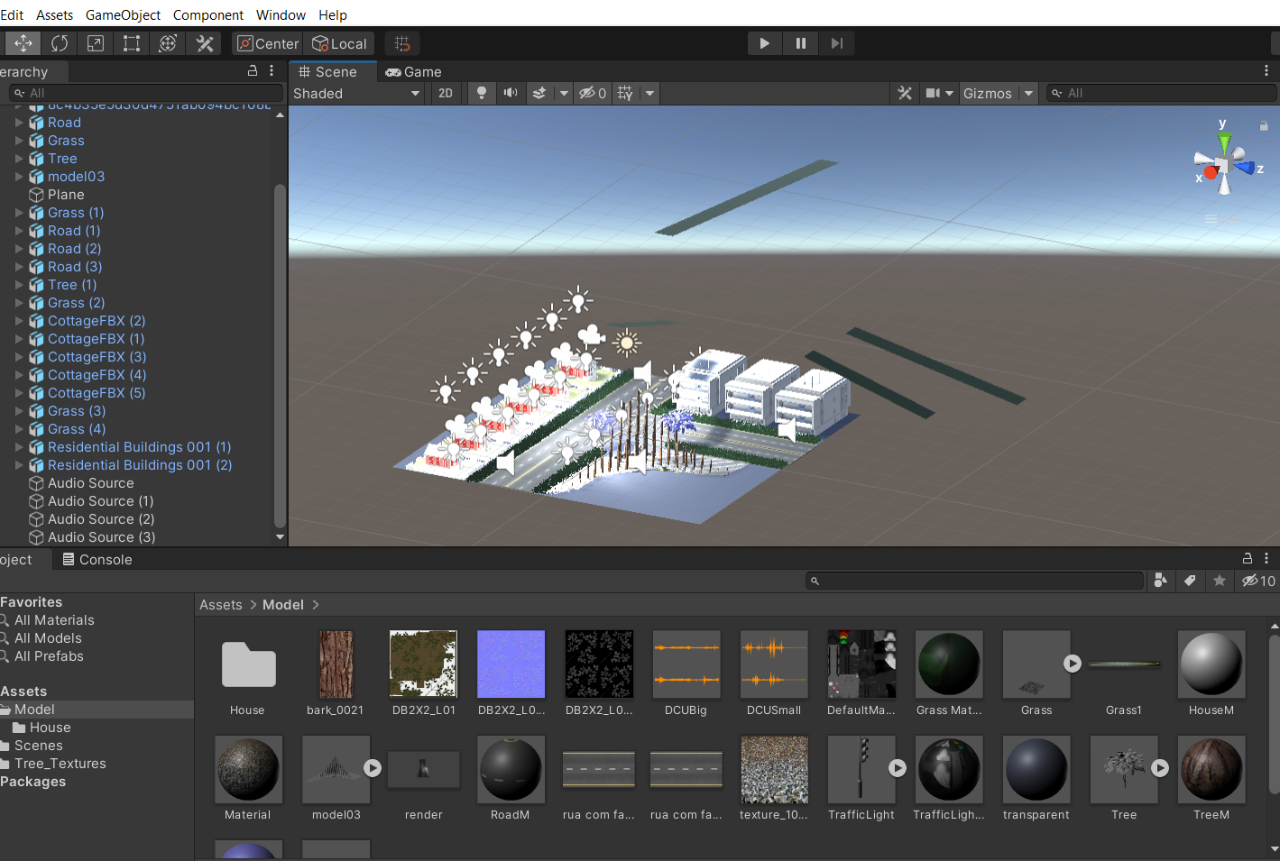

At the end of this step, I uploaded the scene on the AltSpaceVR template. However, again there were problems with the versions since now, it is 11 months after Dr.Young made his tutorial in June 2020.

After another two days of struggle with merely 3 hours of sleep in each day, with the helpful advice from my classmate Mr.Shijun Zhang, I finally found that Unity 2020.3.10f1 is the only correct versions that can upload the template on AltspaceVR successfully among other Unity versions of 2018, 2019, 2020 and 2021.

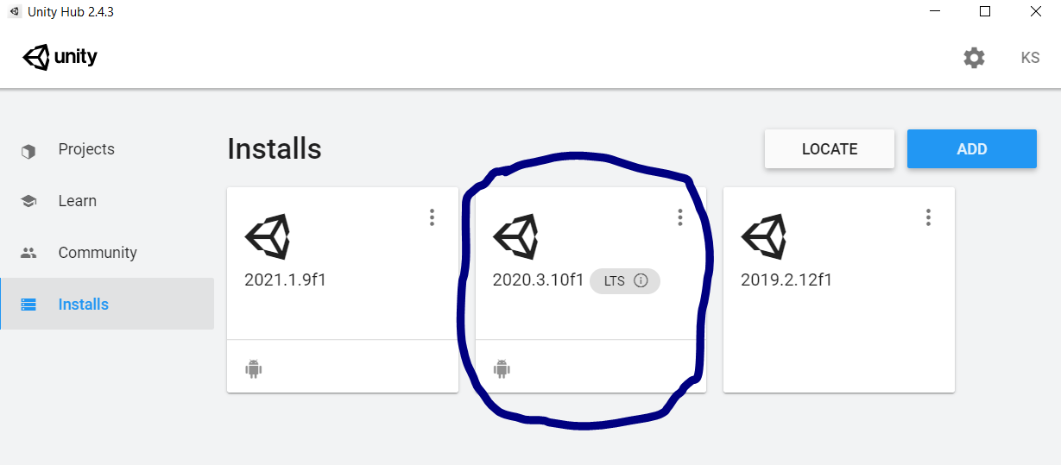

However, after another oversleep ademption until 6 am the next morning, I assumed that the problem is because of the updated version of AltspaceVR. It always shows below error after I tried 17 times for 20 hours without sleep.

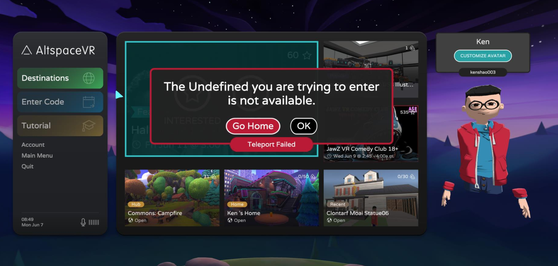

At that moment, I was on the verge of crying and almost desperate, but I never gave up, and continuing previous checked the steps again and again.

After another 5.5 hours checking, at the very last moment, before I nearly gave up, I discovered that if I change to another version of the Unity AltspaceVR uploader, then I could eventually enter the template and view it in AltspaceVR.

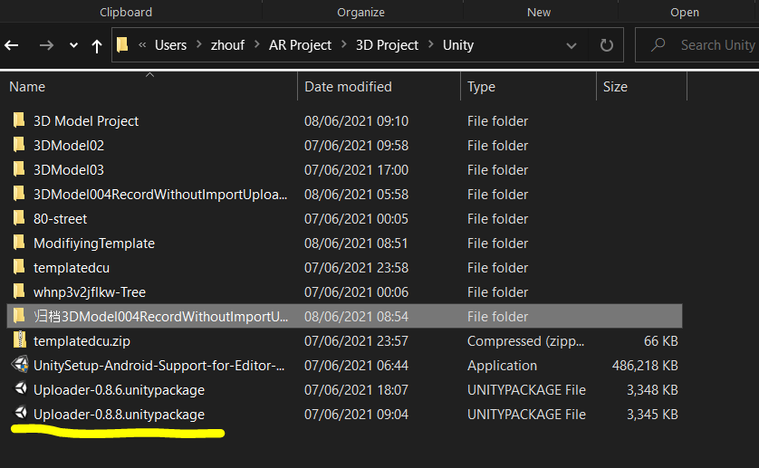

Finally, I created an event, and below is my output, and the Youtube demo is as I mentioned at the starting of this report.

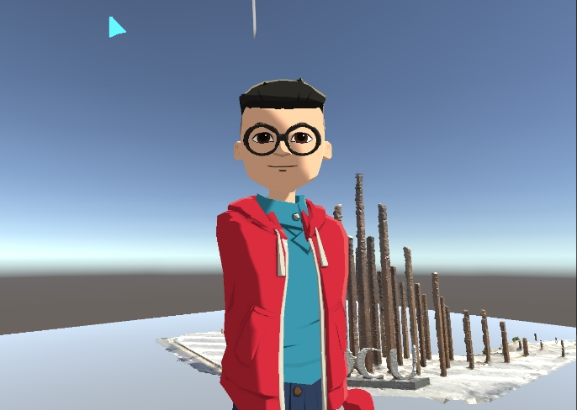

**Additionally, Exercise 3**

I have installed OpenCV followed the latest versions of the instructions, I installed OpenCV and linked it on Virtual Studio C++ with the include and lib settings.

I opened the Chessboard on the second laptop of mine for showing in front of the camera of my current laptop. I started streaming from my webcam using OpenCV, and modified the code example. Then, I have analyzed the algorithms and attempted different approaches. And successfully implemented the functions of findChessboardCorners(), cornerSubPix(), drawChessboardCorners() respectively.

Next, I calculated the intrinsic parameters after modified the given OpenCV code examples. And I wrote another function called solvePnP(). Finally, after drawing the cube, I got the output as below. There is also a Youtube link, as I mentioned at the starting of this report.

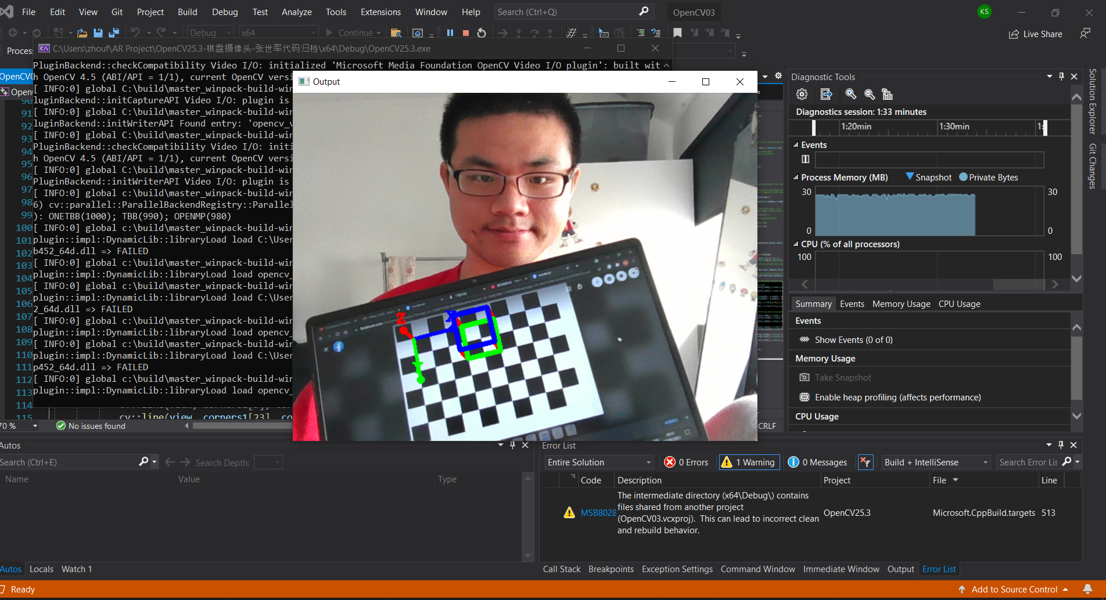

All in all, thanks to Professor Aljosa Smolic, Dr. Gareth Young, and my peers, especially Mr.Shijun Zhang and Mr. Edvinas Teiserskis. Thank those who still keep supporting me, especially after I suffered from one thousand times of failures. I would never forget friends who helped me make some more considerable contributions to society and become successful in the future. I will insist on being persistent to make that day come true.

References:

The related Lecture Notes written by Professor Aljosa Smolic on Blackboard

The Lectures videos recorded by Professor Aljosa Smolic and Dr. Gareth Young on Microsoft Teams

[Ground Truthing and Virtual Field Trips: iLRN 2020 Workshop (virtualarchitectures.github.io)](https://virtualarchitectures.github.io/ground_truthing_and_virtual_field_trips/)

Geometric Algorithms for 3D Interface Reconstruction [ahn_geometry.pdf (lanl.gov)](https://cnls.lanl.gov/~shashkov/papers/ahn_geometry.pdf)

"Soltani, A. A., Huang, H., Wu, J., Kulkarni, T. D., & Tenenbaum, J. B. Synthesizing 3D Shapes via Modeling Multi-View Depth Maps and Silhouettes With Deep Generative Networks. In Proceedings of the IEEE Conference on Computer Vision and Pattern Recognition (pp. 1511-1519)". 6 March 2020.

[(PDF) 3D surface reconstruction using HMH algorithm | Helene COQUEUGNIOT - Academia.edu](https://www.academia.edu/45681098/3D_surface_reconstruction_using_HMH_algorithm)